Info Meeting:

Intention of the meeting is address the GO No GO of Project

UAT sign of today

25th Cab Approval (Change advisory board approval) CAB approval happen on tuesday the team will review the CR and take decision if the approval is received then only the change is applied.

Cab approval

when an application will go live, there is a board meeting happens every tuesday

this board meeting reviews the app that needs to be published (go live)

after the board review and approve the app, it will go to production

the board needs "go" or "conditional go" for them to approve the app to go live

28th Production go live

Final Decision of the project

total 30 observation 28 are fixed 2 are getting ready

Upload File and Approval Information Fix is getting ready

The UAT team has provided few more observation for which team is doing the feasibility analysis and not included in Defct tracker yet.

Supervisor Comment getting deleted scenario.

(if the functionality is not supported by AgilePoint (platform), then it cannot be done.

if the functionality is supported, it can be done but still not sure the timeline)

The team will be rolling off by end of aug/july. and support team can take care of deleting comment functionality.

If NO go happen

slide 2

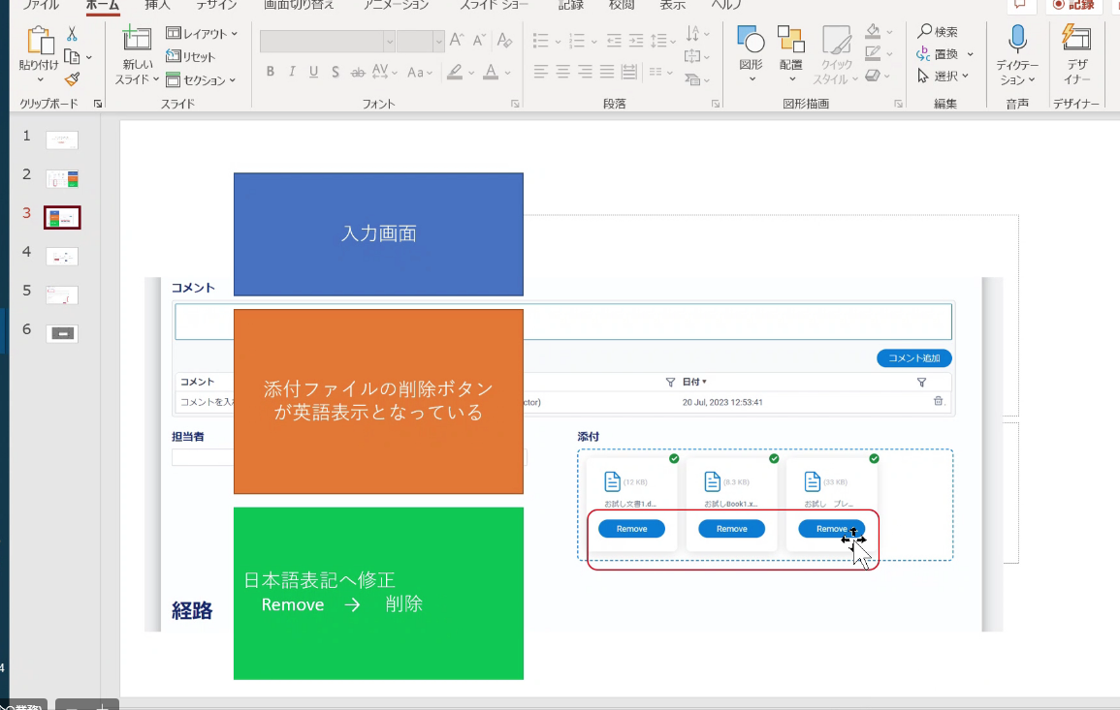

Slide 3 Hide the remove button change the language to japanese.



translation of "Remove Button"

Limitation of customization due to AgilePoint Feature:

if AgilePoint upgraded/make a system version update, then it might be addressed

Slide 4 Enter the Valid {L} should be translated to Japanese

Slide 5 Back and Edit buttonSubject font size in Search

Content view in Search

-> viewing old proposal

Edit/Back - translated

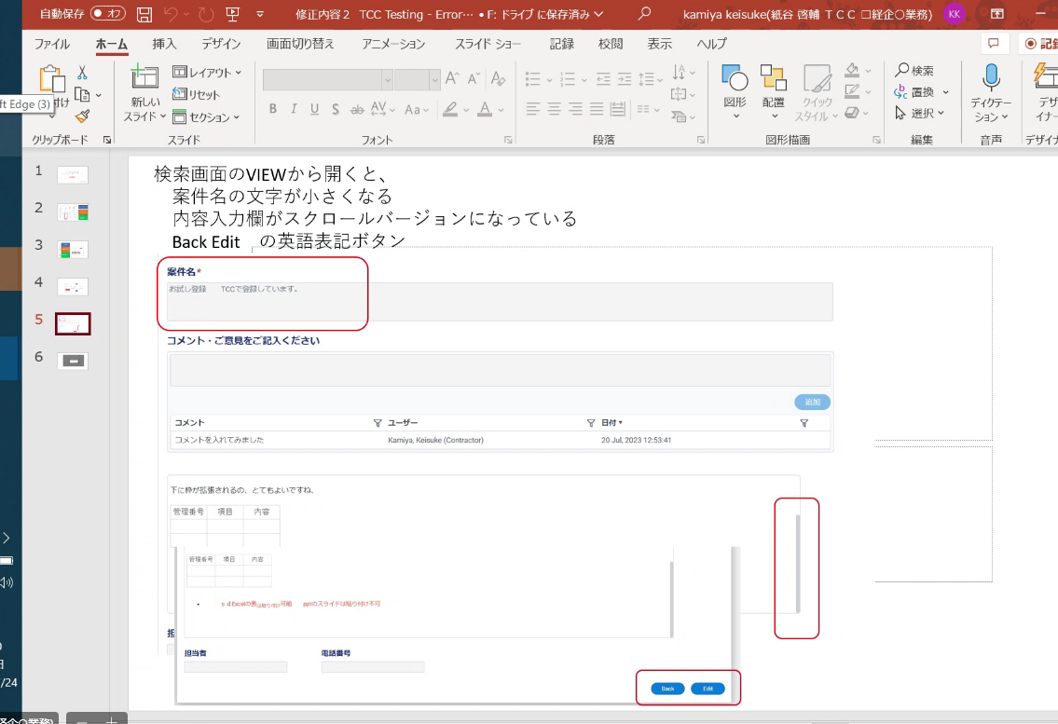

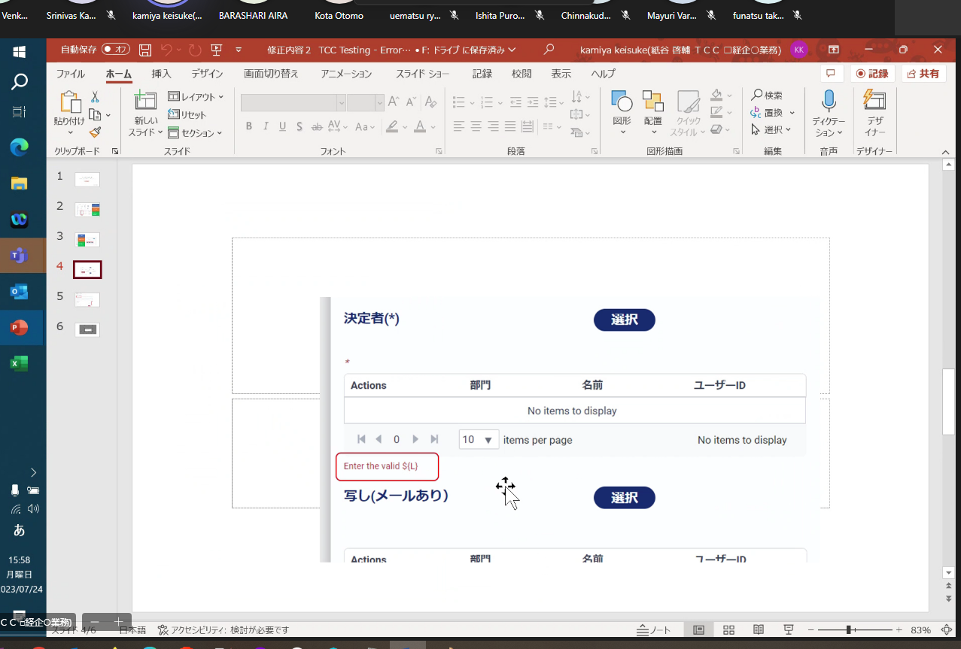

Please open the form, On Toolbar Click on Rules>Select Translator

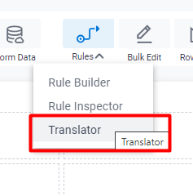

Select Japanese Language and under Library tab select the control which are mandatory and Provide the Validation Message in highlighted textbox and click on “Update” button.

Follow the steps for all the forms and publish the application.

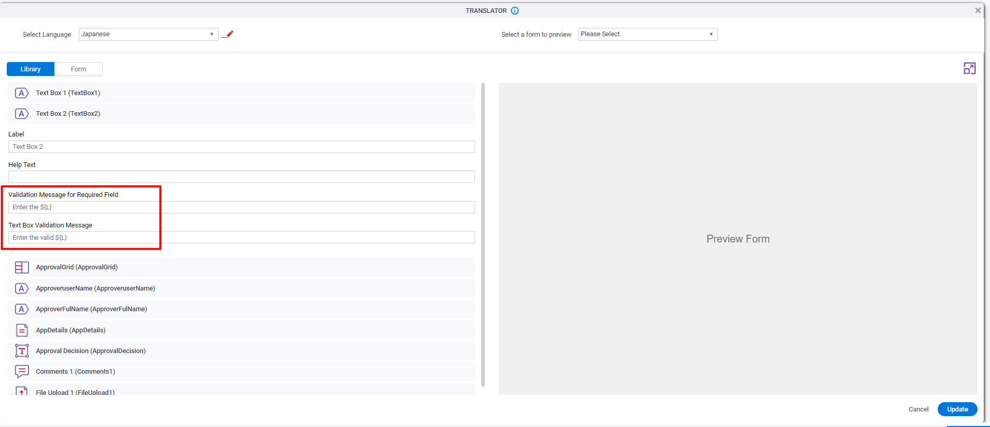

In Runtime when user change the Language to Japanese and if the user try to skip the mandatory fields the validation message will appear in Japanese.



Info Meeting:

Intention of the meeting is address the GO No GO of Project

UAT sign of today

25th Cab Approval (Change advisory board approval) CAB approval happen on tuesday the team will review the CR and take decision if the approval is received then only the change is applied.

Cab approval

when an application will go live, there is a board meeting happens every tuesday

this board meeting reviews the app that needs to be published (go live)

after the board review and approve the app, it will go to production

the board needs "go" or "conditional go" for them to approve the app to go live

28th Production go live

Final Decision of the project

total 30 observation 28 are fixed 2 are getting ready

Upload File and Approval Information Fix is getting ready

The UAT team has provided few more observation for which team is doing the feasibility analysis and not included in Defct tracker yet.

Supervisor Comment getting deleted scenario.

(if the functionality is not supported by AgilePoint (platform), then it cannot be done.

if the functionality is supported, it can be done but still not sure the timeline)

The team will be rolling off by end of aug/july. and support team can take care of deleting comment functionality.

If NO go happen

slide 2

削除